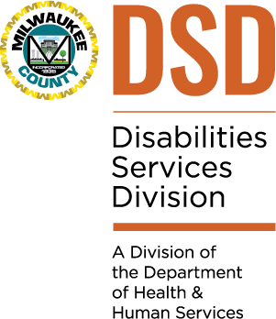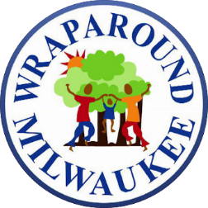Dear Partners and Colleagues,

We wanted to take a moment to reach out to you about the Children’s Integration Project that is currently underway.

Our initial pilot, or Phase One: Joint Intake, involved the combining of Disability Services Division (DSD) and Wraparound Milwaukee Intake Lines into a single Resource & Referral Line. We quickly saw success, and realized continued integration would generate desired outcomes for both areas. We know the changes in Phase One resulted in some growing pains initially, and we thank you for your patience and feedback. The good news is youth and families did not seem to experience challenges, as they have given us a 4.1 out of 5 customer satisfaction rating. Encouraged by these ratings, we want to continue to move toward our goal statement: *Develop a centralized process and information hub for children with disabilities and their families in Milwaukee County to get help, no matter the need or disability by the end of 2020*. Now that Phase One is complete, we are working on Phase Two: Joint Navigation, with plans to move quickly into Phase Three: Integrated Assessments.

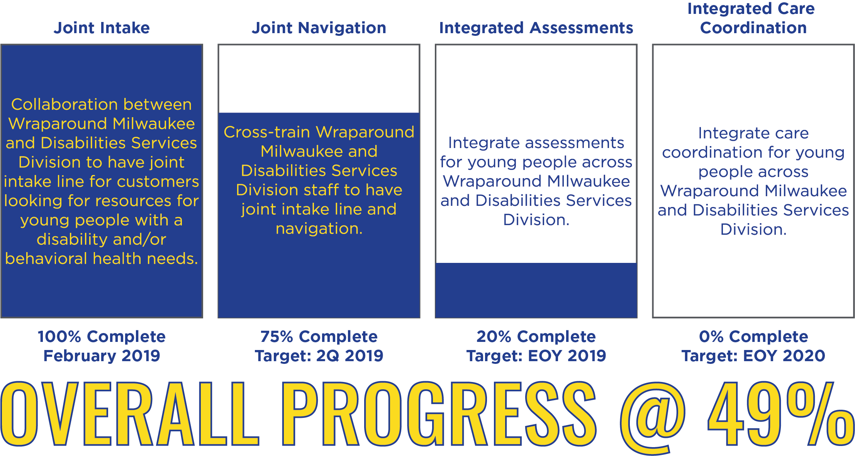

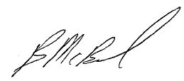We are excited about the opportunities ahead, and the chance to come together to build something entirely new that can be more responsive to the needs of those we serve. Of course, our stakeholders are critically important to the success of this project. Please look for future opportunities to share your ideas, offer insights and provide feedback. All the best,



_________________________ _________________________ _________________________

Mary Jo Meyers Brian McBride Shakita LaGrant

Director, DHHS Director, BHD Children’s Services Assistant Administrator, DSD